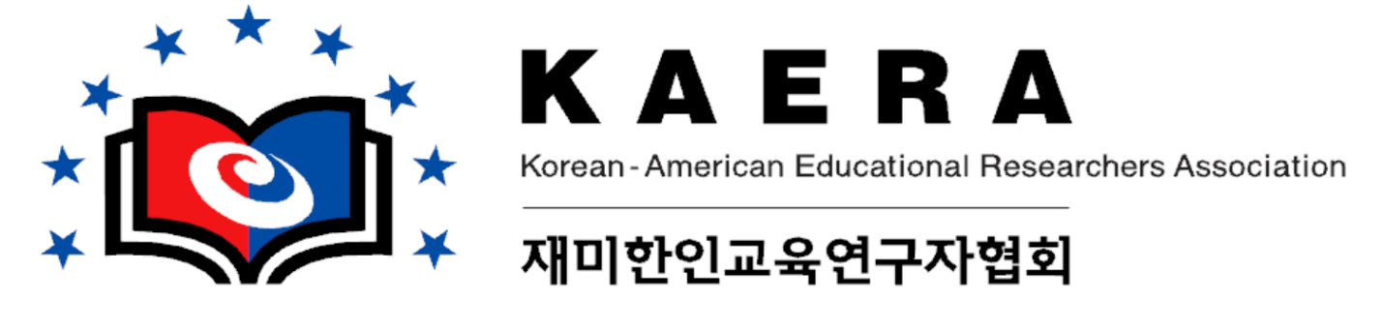

CALL FOR APPLICATIONS
KOREAN-AMERICAN EDUCATIONAL RESEARCHERS ASSOCIATION (KAERA)
MICHAEL B. SALWEN SCHOLARS PROGRAM
EXTENDED APPLICATION DEADLINE: March 17, 2023

Purpose:
As part of its efforts to broaden membership, Korean-American Educational Research Association offers the Michael B. Salwen Scholars Program to support travel expenses for doctoral students, postdoctoral fellows, or junior faculty. It is more than a financial stipend. This Program intends to intellectually support the development of Scholars’ research as well as professional mentoring and network opportunities. To help scholars craft questions, strengthen theoretical frameworks, and improve research skills, Scholars are required to participate in the the KAERA/AERA/NCME annual meeting at which their scholarships will be recognized.

Scholarships:
A maximum of six awards are offered in the amount of $500 each to defray expenses in attending the 2023 KAERA meeting as well as the 2023 AERA/NCME conference. Scholars receive a stipend to be used for conference-related expenses, such as conference registration fee.

Eligibility:
An applicant should meet the following criteria:
- Member of KAERA (i.e., applicants should register for the 2023 KAERA conference);
- Doctoral student or junior scholar within 6 years of completion of doctoral degree; and
- Agreement to participate in the KAERA meeting and the AERA/NCME conference.

Application:
Information about this KAERA Scholars Program, along with the application form, is attached. The information is also available on the KAERA website (www.k-aera.org). Applicants must include the following in the application: (a) the application form, (b) a vita, and (c) a 2-4-page, double-spaced statement of research interests. Please combine these three application materials into one Word or PDF file. Submit your document electronically to the KAERA Michael B. Salwen Scholarship Committee Chair, gcpark@bsu.edu, no later than March 17, 2023.

It is the responsibility of the applicant to ensure that the application is complete and that it has been received by the due date. Please prepare to submit within a reasonable timeframe to avoid the application not being received because of technical issues with e-mail communications.

Selection:
The KAERA Scholars Program Committee will select Scholars based on the academic merits and financial needs of applicants. Selection will favor those who demonstrate that: (a) their research and scholarship will contribute to the knowledge base in their fields and (b) their work will contribute to achieving the mission and goals of KAERA (see the KAERA website, www.kaera.org). These points should be addressed in the statement of research interests. Selection will also favor those who will present their research at the 2023 AERA/ NCME/ KAERA conference.

